**WHERE2PARK**

**Project Report**

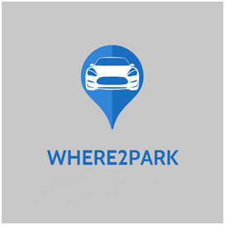

**Ministry/Department Category:** Small

**Problem Statement:** How to find your vehicle in night in a big parking lot. When there is a big ground having thousands of vehicles and you have to find your bike, scooter or cycle?

**Team ID:** TG000775

**College Name:** Raksha Shakti University

**Team Leader Name:** Mr. Akshat Soni

**College Code:** U-0595

|  |  |  |  |
| --- | --- | --- | --- |
| **Sr. No.** | **Topic** | **Page No.** | **Sign** |
| Chapter 1 | 1. Introduction    1. Project Summary & Profile    2. Purpose    3. Scope & Objectives    4. Technologies |  |  |
| Chapter 2 | 1. Project Management    1. Project Planning       1. Project Development Approach and Planning       2. Milestones and Deliverables       3. Roles and Responsibilities    2. Project Scheduling    3. Risk Management |  |  |
| Chapter 3 | 3.0 System Requirements Study  3.1 User Characteristics  3.2 Minimum Hardware & Software Requirements.  3.3 Constraints |  |  |
| Chapter 4 | 4.0 System Analysis  4.1 Feasibility Study  4.2 System Activity Diagram |  |  |
| Chapter 5 | 1. System Design    1. Database Design       * Data Dictionary       * ER Diagram       * Data Flow Diagram    2. Input/output and Interface Design       * State Transition Diagram/UML Diagram/Flow Chart    3. Samples of Forms, Report, and Interface |  |  |
| Chapter 6 | 1. Implementation Planning    1. Implementation Environment    2. Program/ Module Specification |  |  |
| Chapter 7 | 1. Testing    1. Testing Planning & Strategy    2. Testing Principle    3. Testing Methods    4. Levels of Testing |  |  |
| Chapter 8 | 8.0 Future Enhancement  8.1 Future Enhancement & Scope |  |  |

**Abstract**

**:** We will build a web based system for users to check for the vacant block for their vehicle to be parked-in, the user will open the system and will look for the vacant blocks from the layout provided on the website by just entering their vehicle registration no. and their name, the users will be informed regarding the parking block information through the sms/mail/on-screen notification, so that they can easily find their vehicle just looking into the message/notification. The parking block will be vacant by the user himself or the parking lot admin, they can simply vacant the block by the option provided in the system.

**Chapter 1**

1. **Introduction**

**1.1 Project Summary &Profile :**

|  |  |
| --- | --- |
| **Project Name** | WHERE2PARK |
| **Project Type** | Web Application/Website |
| **Technology** | PHP, JS |
| **DataBase Manager** | MySQL |
| **Institute Name** | Raksha Shakti University |
| **Development Team** | -Akshat Soni (Team Leader) -Shrey Patel -Nishant Bharat -Himanshu Prajapat -Bhakti Rana -Hardik Varma -Sohil Khan |
| **Mentor/Guide** | Prof. Archana Gondalia |

**1.2Purpose :**

**1.3 Scope &Objectives :**

**1.4 Technologies :(HTML&CSS,PHP,MySQL,JS)**

* For the Front-End Development we have used HTML & CSS.
* For the Scripting we have used PHP(Hypertext Pre-Processor).
* To manage the Back-End i.e. Database of the System, we have used MySQL.

**IDE:**

Notepad++:- It supports tabbed editing, which allows working with multiple open files in a single window.

**Server :**

Apache:- Apache supports a variety of features to extend the core functionality. A server is required for running PHP script Apache will be used in our project.

**Languages:**

PHP:- Hypertext Preprocessor is a server-side scripting language designed for Web development.

**Scripts:**

Java Script:- JavaScript is a scripting and GUI handling language. Java Script will be used for scripting GUI based controls.

CSS:- Cascading Style Sheets is a style sheet language used for describing the presentation of a document written in a markup language like HTML. CSS will be used for describing the presentation of Web pages, including colors, layout and fonts.

**Database:**

MySQL:- MySQL is a Relational Database Management System (RDBMS) that uses Structured Query Language (SQL). As user has to enter some data and it has to be stored as Data storage is required MySQL will used.

**Chapter 2**

**2.0 Project Management**

**2.1 Project Planning & Scheduling:**

* + 1. **Roles and Responsibilites:**

Our system was decomposed into different modules and our team is responsible person for analysis, design, and implementation, documentation, etc. along with the testing.

|  |  |
| --- | --- |
| **Activities** | **Responsibility** |
| Requirement Gathering | Akshat Soni |
| Analysis | Akshat Soni Shrey Patel Bhakti Rana Nishant Bharat |
| Design | Bhakti Rana Shrey Patel |
| Database | Himanshu Prajapat Sohil Khan |
| Implementation | Akshat Soni Nishant Bharat Hardik Varma |
| Testing | Akshat Soni |
| Documentation | Akshat Soni Bhakti Rana Shrey Patel Nishant Bharat |

**Chapter 3**

**3.0 System Requirement and Study**

**3.1 User Characteristics:**

**System Requirement Specification:**

**Chapter 4**

**4.0 System Analysis**

**4.1 Feasibility Study :**

: According to the existing system for parking, the parking slips are given to users to allot the space for parking their vehicle, and user has to remember where their vehicle was parked and using this method it becomes difficult to find vehicle specially in the night conditions, also there is no systematic parking everywhere, users sometimes have to find a place by themselves to park the vehicle or they have to adjust others vehicles to park their own vehicle. And this problem becomes more complex when the situation is of night hours.

**4.2 System Activity Diagram :**

**Chapter 5**

**5.0 System Design**

1. **Database Design :**
2. **Data Dictionary :**

**Data Dictionary of Our System:**

1. **ER Diagram :**

**ER Diagram of Our System:**

1. **Data Flow Diagram :**

**DFD of Our System:**

1. **Input and Output Interface Design:**
2. **State Transition Diagram/UML Diagram/Flow Chart:  
   UML UseCase Diagram of Our System**
3. **Samples Of Forms, Reports and Interface:**

**Chapter 6**

**6.0 Implementation Planning**

1. **Implementation Environment :**
2. **Programs/Module Specification:**

**Chapter 7**

**7.0 Testing**

**What would be your approach to solve the problem:**

: In our approach, The parking lot will be divided into two blocks for Two-Wheeler, Four-Wheeler. There will be separate slots for each vehicle in both the blocks. The user will require to login to the website. The user will be provided the layout of the parking lot on the website from which the parking slots will be alloted to the user, after allotting the parking slots, the user will receive a text message containing the information regarding the alloted slot, in this way the problem of locating the in the parking will be solved.

**Chapter 8**

**8.0 Future Enhancement**

### 8.1 Future Enhancement and Scope

* + Currently, 2 users are supported in the chatting module and Documents are stored in folders.
  + In future, the multi user chatting environment will be provided for faculties to answer doubts user specifically.
  + In future the faculties will be able to arrange files using folders.
  + Improvement in User Interface.

**Flow Diagram of Solution:**

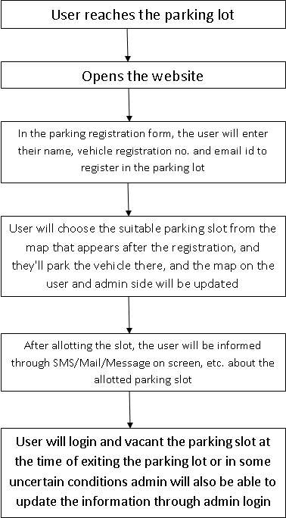

**Challenges/Risk in implementing your Final prototype:**

1. Usually the current parking spaces available are the simple open space and we need to update that space by dividing the whole pace among various slots and do the naming of them as well. It requires time and efforts and by the time these physical installation takes place the parking space will be unnecessarily busy.

2. Parking space is filled according to slots available, so it is to be ensured that there is an efficient way of parking so that each vehicle get proper position and from there they can easily get out.

3. At some areas mobile network is not available so it causes problem for the user to logon to the website and select the parking space.

**Possible outcome of your work:**

: As per the definition of the problem we tried to come up with the optimum solution according to us. The user will be able to easily find the vehicle in the parking lot as they will be having information about the exact location of the vehicle, in a form of block number (selected by themselves ) in which they

have parked the vehicle, so it will become so easier rather than wasting time in randomly and cluelessly finding the vehicle in the huge parking lot. As well as it is affordable and reliable project to set up with possibly minimum expense that is eventually a big plus point for the developer also that they will not have to invest somewhat good amount.

**Work done till date:**

Front End Planning: Front-End Planning is under progress, we have designed some templates for the webpages like template for the parking lot map page, the template for the vehicle registration form, etc. which are also there in attachments.

Front End Implementation: This task is under planning right now, we will start implementing the GUI soon as the planning completes, the GUI will be implemened with the help of HTML, CSS, & JavaScript (jQuery).

Back End Planning: Back Planning is also under progress, we have designed the templates and we are planning for the backend implementation through PHP and JavaScript.

Database Planning & Management: We have also planned the datas to be stored and we have also almost completed the database planning.

Overall progress of the project is almost 30%.

**Image/Screenshot/Video link of our solution:**

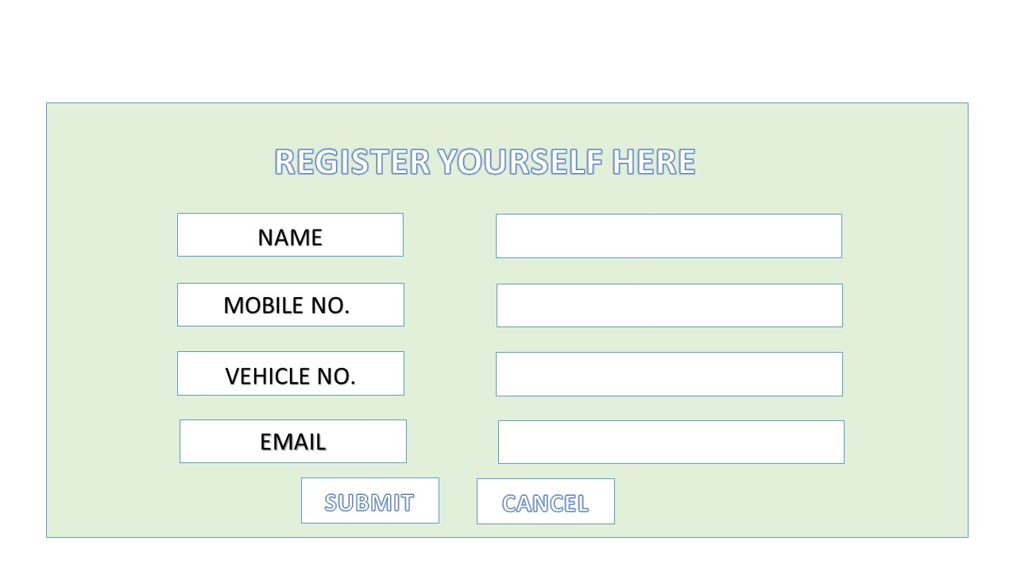

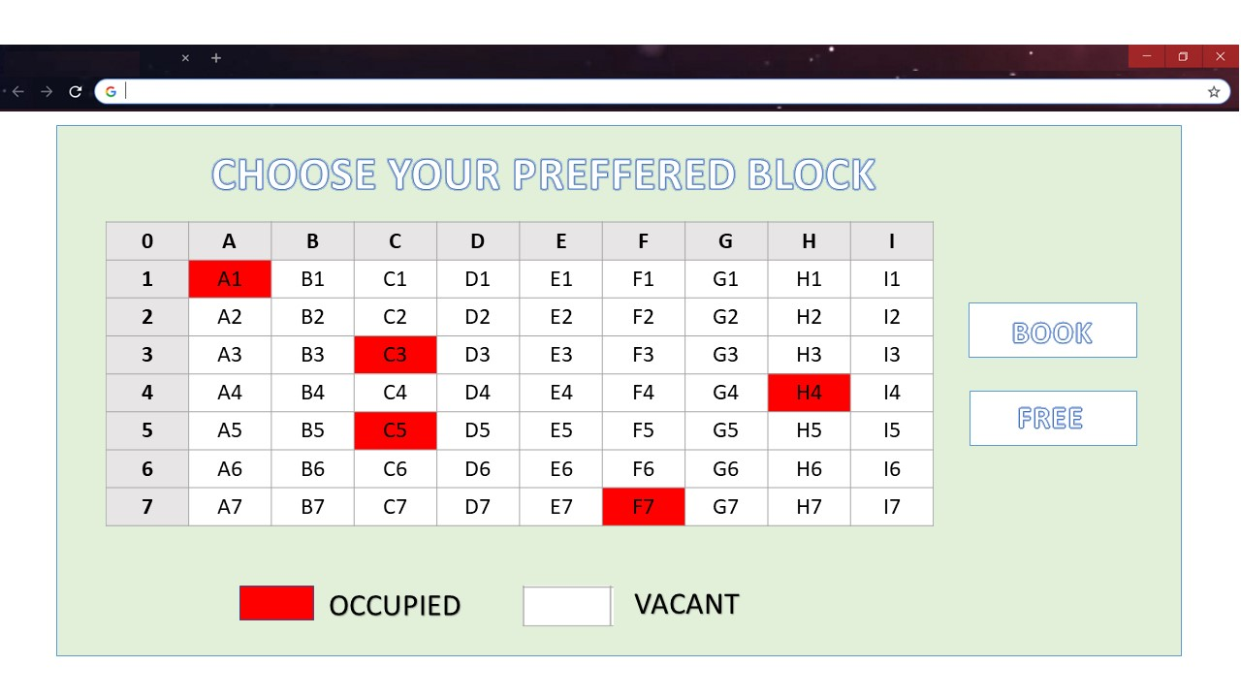

(This is planned design of the solution not the actual design)